{Pattern Detector Block}

{1/12/2025}

{Shulamit Karlibach, Malka Rechnitzer, Racheli Ostrov}

Content

Glossary and references 3
RTL Block Description 3
RTL Block Diagram 3
DUT interface 4
Verification Block Diagram 4
Verification Checkers and Assertions שגיאה! הסימניה אינה מוגדרת.
Waves 5
Test List 5
Coverage Plan 6
Coverage Result 6
Disclaimers 6
Open Issues / TODO List 6

Glossary and references

• Pattern Match: A process in which the block checks whether there is a 32-bit pattern that appears in both 64-bit data streams. The match can occur anywhere in the stream, and in both operation modes (Full Adjustment Mode and Mask-Based Mode).

• Full Adjustment Mode: In this mode, the block searches for a match of the entire 32-bit pattern between the two data streams, regardless of the pattern’s location within the stream.

• Mask-Based Mode: In this mode, the block uses a 32-bit mask to determine which bits of the pattern should be compared. Only the bits where the mask contains a “1” will be checked.

• DUT (Device Under Test): The device being tested—in this case, the Pattern Detector Block where all functions and requirements are verified.

.

References

RTL Block Description

RTL Block Description
The Pattern Detector block is designed to monitor two 64-bit data streams and detect when
they contain the same 32-bit pattern. The block operates in two distinct modes: full
adjustment mode and mask-based mode. When a pattern match is detected according to the
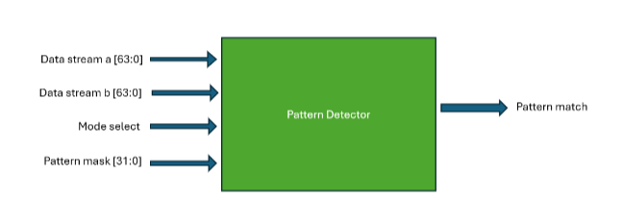
active mode’s criteria, the block asserts an output signal.
RTL Block Diagram

DUT interface

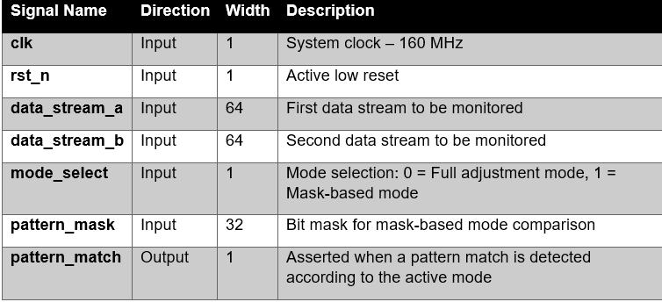
Verification Block Diagram

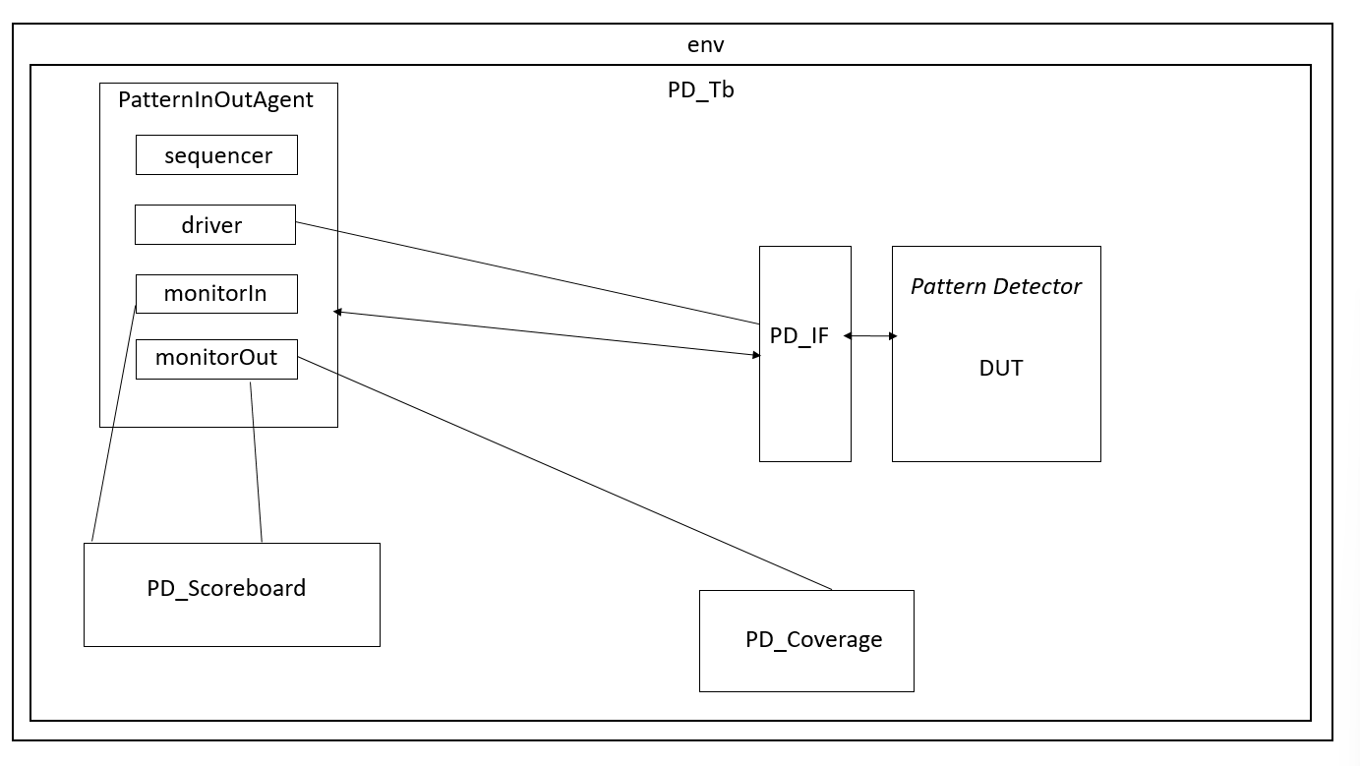

Verification Checkers and Assertions

Waves
אחרי שגומרים לעבוד על הפרויקט

Test List

Test ID | Test Name | Mode | Description / Steps | Expected Result
1.1 | PD_Full_BasicMatch_test | Full | A and B contain one identical 32-bit window | pattern_match = 1
1.2 | PD_Full_NoMatch_test | Full | No identical window exists | pattern_match = 0
1.3 | PD_Full_FirstWindowMatch_test | Full | Match occurs in the first window (bits 0–31) | pattern_match = 1
1.4 | PD_Full_LastWindowMatch_test | Full | Match occurs in the last window (bits 32–63) | pattern_match = 1
1.5 | PD_Full_MultipleMatches_test | Full | 2–3–10 matching windows | pattern_match = 1
2.1 | PD_Mask_FullMask_test | Mask | mask = all 1’s | Same as Full Mode
2.2 | PD_Mask_ZeroMask_test | Mask | No bits are compared (mask = 0) | pattern_match = 0
3.1 | PD_ResetFunctionality_test | N/A | Apply reset and verify all internal registers and outputs return to default values | Outputs return to reset state (pattern_match = 0)
3.2 | PD_Reset × Match_test | {match after reset, no_match after reset} | Right after deassert | Checks that there is no false match after reset
4.0 | PD_Mode Transitions_test | {0→1, 1→0} | when changing a mode_select | Checks logical stability in state change at runtime

Coverage Plan

Coverage Item | Bins | Sample Time | Description / Comment
Mode Select | {0, 1} | When we have match | Coverage of both operation modes: Full / Mask
Window Index A | 0–32 | On receiving data_stream_a | Coverage of all 33 possible windows in Stream A
Window Index B | 0–32 | On receiving data_stream_b | Coverage of all 33 possible windows in Stream B
Window Alignment Cross | All combinations A×B (33×33) | Every match | Required by SPEC — coverage of all possible window pairs
Pattern Types | {equal, different, overlapping, all-zero, all-one, alternating, random} | On input change or pattern detection | Full coverage of all defined pattern types
Mask Patterns | {0x00000000, 0xFFFFFFFF, 1-bit mask, continuous bits, sparse bits} | During mode = 1 | Ensures all mask types are covered
Transition × Match | All combinations | During a status change | Algorithm behavior under mid-test state changes
Boundary Windows | {window 0, window 32} | When checking a window | Windows Edge — Critical due to 64→32 bit architecture

Coverage Result

Disclaimers

Open Issues / TODO List

